Query the view to calculate cohort-level CLTV metrics
This query aggregates Customer Lifetime Value (CLTV) metrics from vw_channel_cohorts by grouping customers into acquisition channels. It calculates key performance indicators for each cohort, including unique customer counts, total orders, revenue, average order value, purchase frequency, and historical CLTV. The output ranks customer acquisition channels by profitability, showing "Referral / Direct / Other" generates the highest historical CLTV ($12,155.96) and "Paid Ads" drives the highest total volume.

QUERY-;
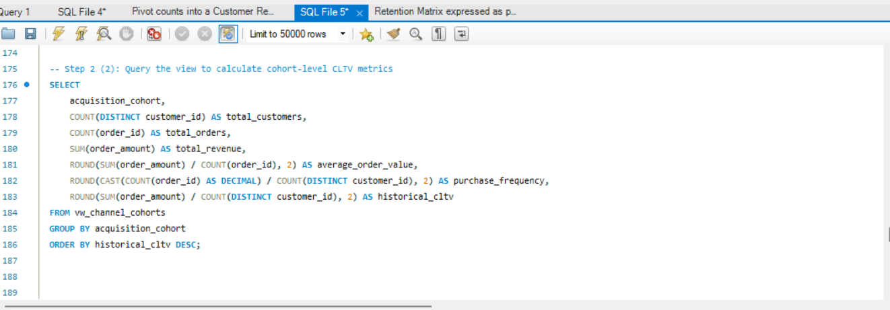

OUTPUT-;

